Defense evasion opening ports case:
Since case is related to opening port start search with allow keyword.
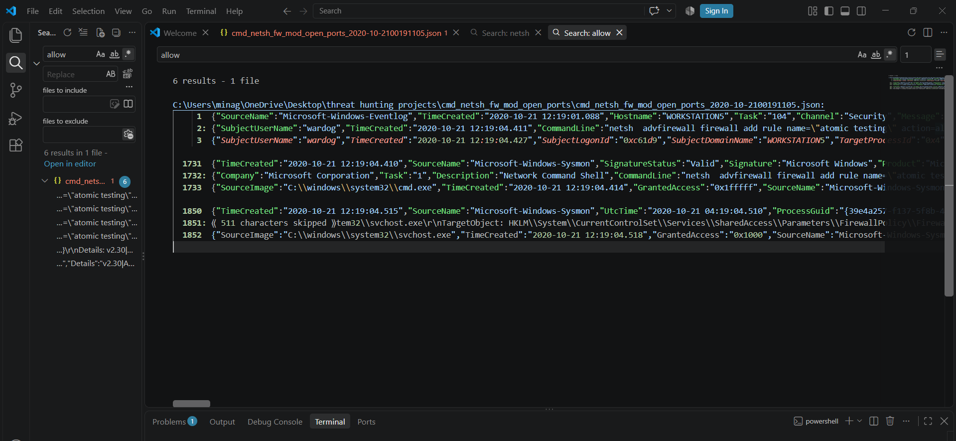

The command add rule allows the port 450 inbound traffic with rule name of atomic testing.

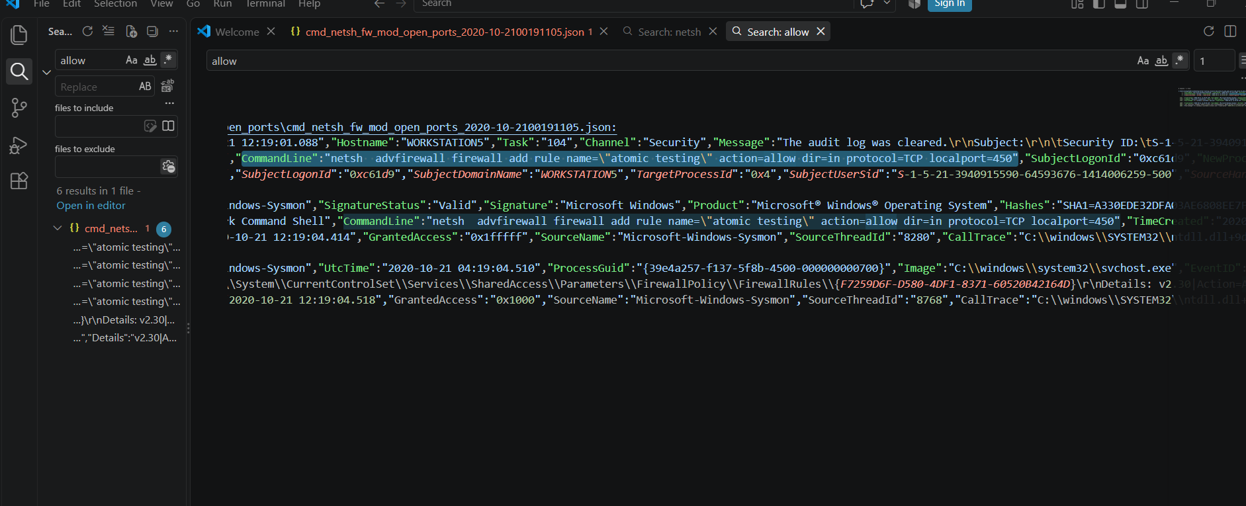

Observed registry modification to enable this rule
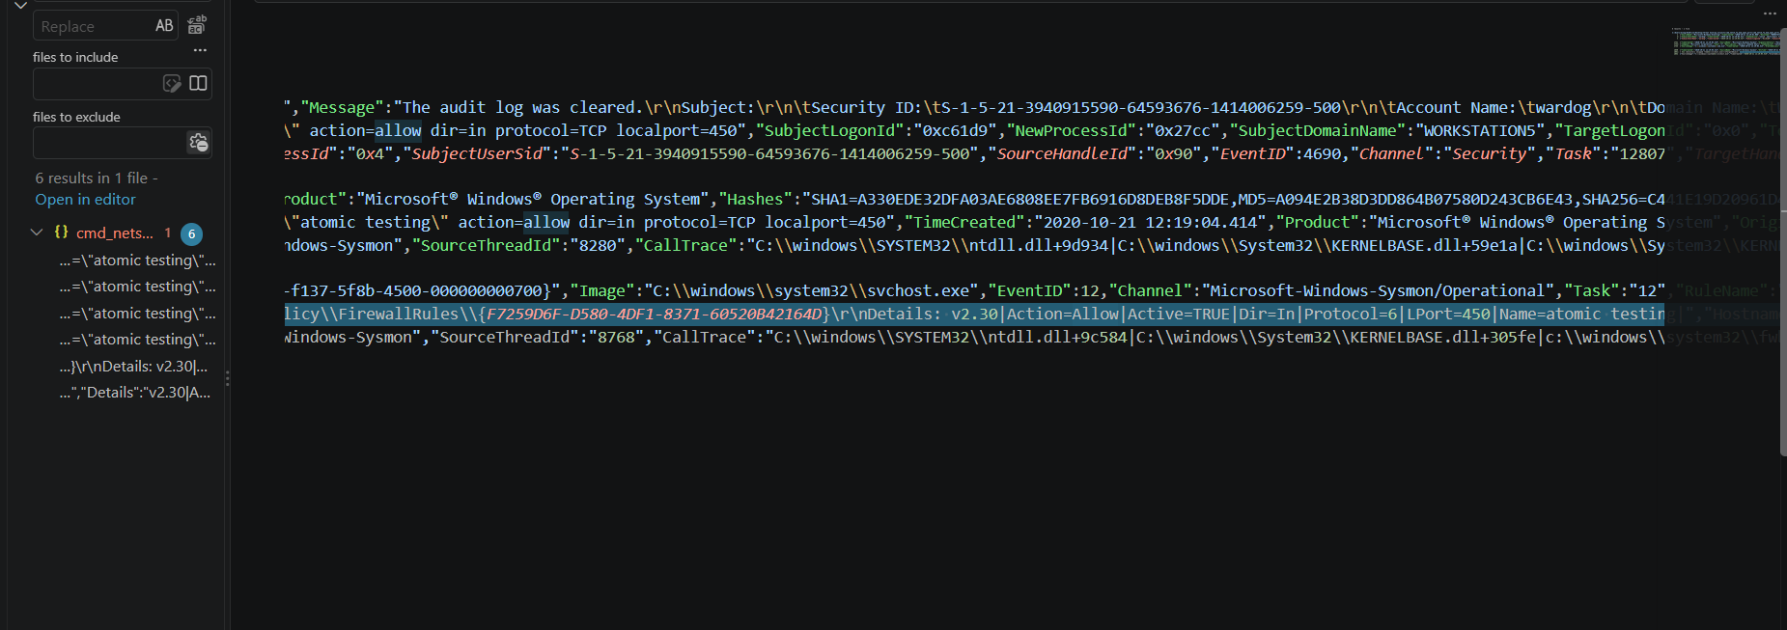
Then deletes the same rule.
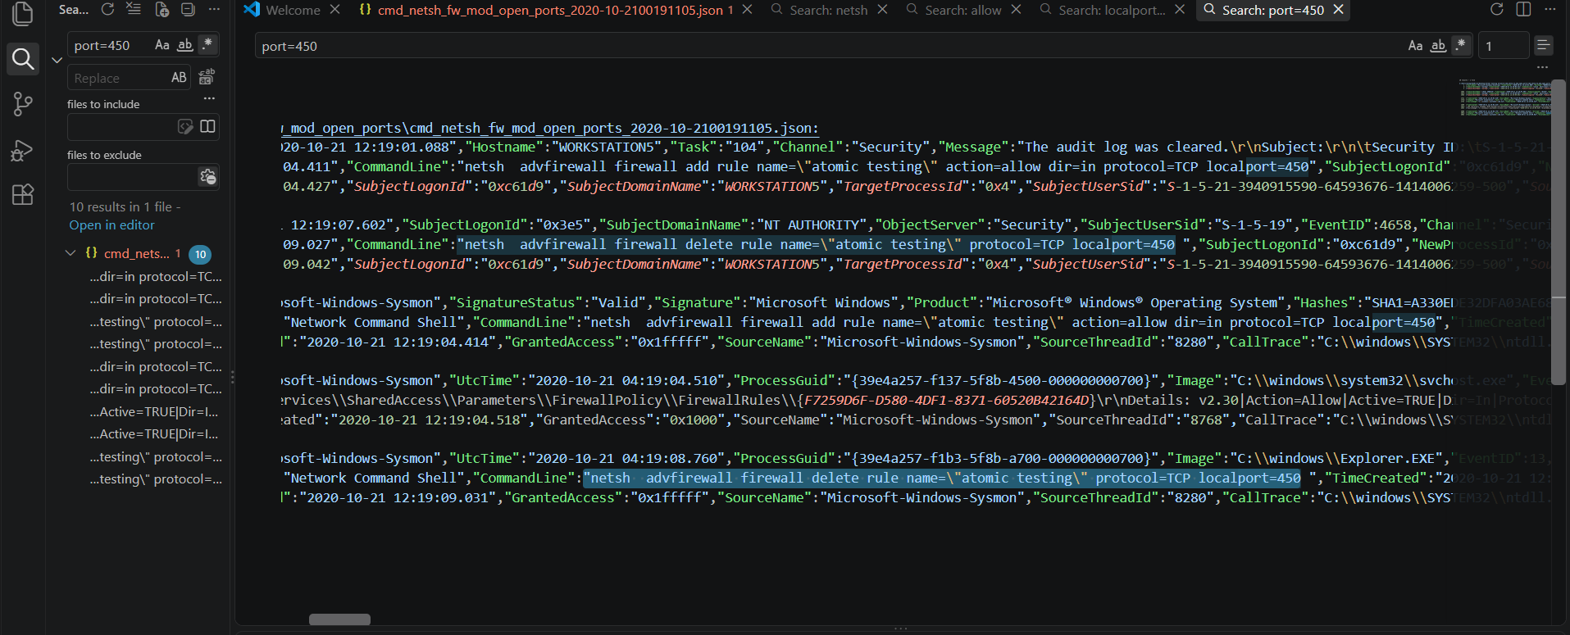

Overall activity:

In this incident the netsh is used to add and delete the rule with allows the port 450 inbound traffic and observed registry changes in firewall rules.

